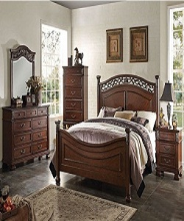

Simple Luxury Bed

$189.54

Availability: In stock

Description

Simple brown wood bed with crown shaped back. Traditional style with Dark walnut finish. Made from Pine wood solids and veneers. Panel bed features PU padded headboard with oversized posts finials and canopy accented with decorative hardware and moldings. Available in King, California King and queen sizes. Also a nightstand features 3 drawers with felt lined top drawer accented with burnished silver drawer pulls in a full extension side metal ball bearing glides.